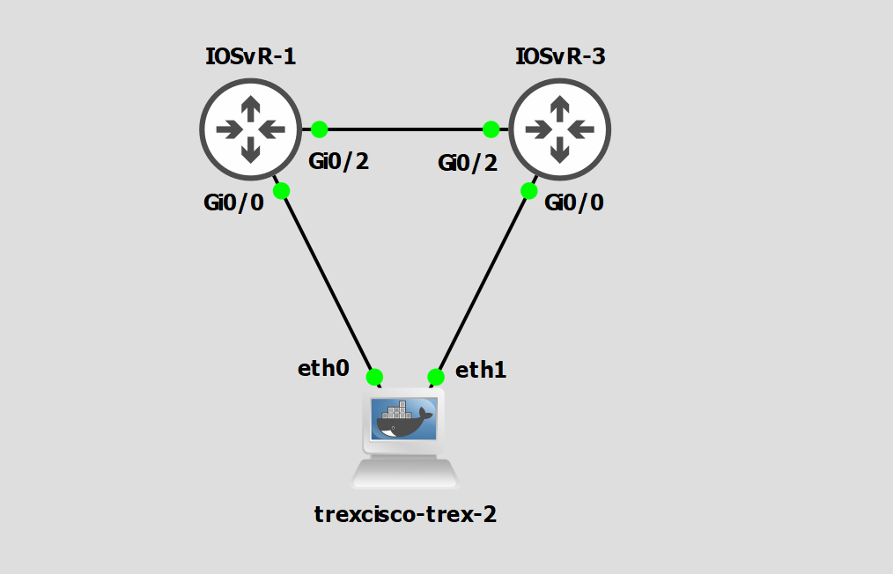
R1#show inter gi 0/0
GigabitEthernet0/0 is up, line protocol is up
Hardware is iGbE, address is 0c2f.6e70.0000 (bia 0c2f.6e70.0000)
Internet address is 10.10.10.1/30
MTU 1500 bytes, BW 1000000 Kbit/sec, DLY 10 usec,
reliability 255/255, txload 1/255, rxload 1/255
Encapsulation ARPA, loopback not set
Keepalive set (10 sec)
Auto Duplex, Auto Speed, link type is auto, media type is RJ45
output flow-control is unsupported, input flow-control is unsupported
ARP type: ARPA, ARP Timeout 04:00:00
Last input 00:00:57, output 00:00:08, output hang never
Last clearing of "show interface" counters 02:54:12
Input queue: 0/75/0/1148241 (size/max/drops/flushes); Total output drops: 0
Queueing strategy: fifo
Output queue: 0/40 (size/max)
5 minute input rate 0 bits/sec, 0 packets/sec
5 minute output rate 0 bits/sec, 0 packets/sec
13994 packets input, 4986452 bytes, 0 no buffer
Received 53 broadcasts (0 IP multicasts)
0 runts, 0 giants, 0 throttles
0 input errors, 0 CRC, 0 frame, 0 overrun, 0 ignored
0 watchdog, 0 multicast, 0 pause input
2363 packets output, 240353 bytes, 0 underruns
0 output errors, 0 collisions, 0 interface resets
0 unknown protocol drops
0 babbles, 0 late collision, 0 deferred
0 lost carrier, 0 no carrier, 0 pause output
0 output buffer failures, 0 output buffers swapped out

R3#show inter gi 0/0
GigabitEthernet0/0 is up, line protocol is up
Hardware is iGbE, address is 0cd2.b4d8.0000 (bia 0cd2.b4d8.0000)
Internet address is 7.7.7.1/30
MTU 1500 bytes, BW 1000000 Kbit/sec, DLY 10 usec,
reliability 255/255, txload 1/255, rxload 1/255
Encapsulation ARPA, loopback not set
Keepalive set (10 sec)
Auto Duplex, Auto Speed, link type is auto, media type is RJ45
output flow-control is unsupported, input flow-control is unsupported
ARP type: ARPA, ARP Timeout 04:00:00
Last input 00:00:57, output 00:00:05, output hang never
Last clearing of "show interface" counters 02:54:13
Input queue: 0/75/0/0 (size/max/drops/flushes); Total output drops: 0
Queueing strategy: fifo
Output queue: 0/40 (size/max)
5 minute input rate 0 bits/sec, 0 packets/sec
5 minute output rate 0 bits/sec, 0 packets/sec
53 packets input, 3180 bytes, 0 no buffer
Received 53 broadcasts (0 IP multicasts)
0 runts, 0 giants, 0 throttles
0 input errors, 0 CRC, 0 frame, 0 overrun, 0 ignored
0 watchdog, 0 multicast, 0 pause input
2356 packets output, 238948 bytes, 0 underruns
0 output errors, 0 collisions, 0 interface resets
0 unknown protocol drops
0 babbles, 0 late collision, 0 deferred
0 lost carrier, 0 no carrier, 0 pause output
0 output buffer failures, 0 output buffers swapped out

R1#show ip int br
Interface IP-Address OK? Method Status Protocol
GigabitEthernet0/0 10.10.10.1 YES manual up up
GigabitEthernet0/1 unassigned YES TFTP administratively down down
GigabitEthernet0/2 13.1.1.1 YES manual up up
GigabitEthernet0/3 unassigned YES unset administratively down down
R1#show run | sec ospf
router ospf 1
network 0.0.0.0 255.255.255.255 area 0

R3#show ip int br
Interface IP-Address OK? Method Status Protocol
GigabitEthernet0/0 7.7.7.1 YES manual up up
GigabitEthernet0/1 unassigned YES unset administratively down down
GigabitEthernet0/2 13.1.1.2 YES manual up up
GigabitEthernet0/3 unassigned YES unset administratively down down
R3#show run | sec ospf
router ospf 1
network 0.0.0.0 255.255.255.255 area 0

Docker hub is located docker hub
Pull the trex image
[bash]>docker pull trexcisco/trex #
[bash]>docker run --rm -it --privileged --cap-add=ALL trexcisco/trex #
[bash]root@d8ec7a3a09d9 v2.36]./t-rex-64 -i #

[root@trexcisco-trex-2 v2.41]# cat /etc/trex_cfg.yaml
- port_limit : 2
version : 2
low_end : true
interfaces : ["veth0", "veth1"] # list of the interfaces to bind run ./dpdk_nic_bind.py --status
port_info : # set eh mac addr

- ip : 10.10.10.2
default_gw : 10.10.10.1
dest_mac : "0c:2f:6e:70:00:00"
- ip : 7.7.7.2
default_gw : 7.7.7.1
dest_mac : "0c:d2:b4:d8:00:00"

[root@trexcisco-trex-2 v2.41]# cat /etc/trex_cfg.yaml
- port_limit : 2
version : 2
low_end : true
interfaces : ["veth0", "veth1"] # list of the interfaces to bind run ./dpdk_nic_bind.py --status
port_info : # set eh mac addr

- ip : 10.10.10.2
default_gw : 10.10.10.1
dest_mac : "0c:2f:6e:70:00:00"
- ip : 7.7.7.2
default_gw : 7.7.7.1
dest_mac : "0c:d2:b4:d8:00:00"

[root@trexcisco-trex-2 v2.41]# ./t-rex-64 -i
Killing Scapy server... Scapy server is killed
Starting Scapy server.... Scapy server is started
The ports are bound/configured.
Starting TRex v2.41 please wait ...
EAL: Started without hugepages support, physical addresses not available
set driver name net_af_packet
driver capability :
Number of ports found: 2
zmq publisher at: tcp://*:4500
wait 1 sec .
port : 0
------------
link : link : Link Up - speed 10000 Mbps - full-duplex
promiscuous : 0
port : 1
------------
link : link : Link Up - speed 10000 Mbps - full-duplex
promiscuous : 0
number of ports : 2
max cores for 2 ports : 1
max queue per port : 3
-------------------------------
RX core uses TX queue number 0 on all ports
core, c-port, c-queue, s-port, s-queue, lat-queue
------------------------------------------
1 0 0 1 0 0
-------------------------------

-Per port stats table
ports | 0 | 1
-----------------------------------------------------------------------------------------
opackets | 0 | 0
obytes | 0 | 0
ipackets | 0 | 0
ibytes | 0 | 0
ierrors | 0 | 0
oerrors | 0 | 0
Tx Bw | 0.00 bps | 0.00 bps

-Global stats enabled
Cpu Utilization : 0.0 % 0.0 Gb/core
Platform_factor : 1.0
Total-Tx : 0.00 bps
Total-Rx : 0.00 bps
Total-PPS : 0.00 pps
Total-CPS : 0.00 cps

Expected-PPS : 0.00 pps
Expected-CPS : 0.00 cps
Expected-BPS : 0.00 bps

Active-flows : 0 Clients : 0 Socket-util : 0.0000 %
Open-flows : 0 Servers : 0 Socket : 0 Socket/Clients : -nan
drop-rate : 0.00 bps
current time : 1.8 sec
test duration : 0.0 sec

From another terminal

muji  docker ps
CONTAINER ID IMAGE COMMAND CREATED STATUS PORTS NAMES
daf5523dd248 trexcisco/trex:latest "/gns3/init.sh /bin/…" 12 hours ago Up 2 hours GNS3.trexcisco-trex-2.73354e45-bc2c-442c-a6ff-8c6138d273c2

muji  docker exec -it daf5523dd248 bash
[root@trexcisco-trex-2 v2.41]#

[root@trexcisco-trex-2 v2.41]# ./trex-console

Using 'python' as Python interpeter

Connecting to RPC server on localhost:4501 [SUCCESS]

Connecting to publisher server on localhost:4500 [SUCCESS]

Acquiring ports [0, 1]: [SUCCESS]

Server Info:

Server version: v2.41 @ STL
Server mode: Stateless
Server CPU: 1 x Intel(R) Xeon(R) CPU E5-2620 v4 @ 2.10GHz
Ports count: 2 x 10Gbps @ Unknown

-=TRex Console v2.0=-

Type 'help' or '?' for supported actions

trex>service -a # Servis moduna gir
trex>arp --port 0 # Port 0 için ARP çözümlemesi yap
trex>service --off # Servis modundan çık

trex(service)>ping -p 0 -d 10.10.10.1

Pinging 10.10.10.1 from port 0 with 64 bytes of data:
Reply from 10.10.10.1: bytes=64, time=23.66ms, TTL=255
Reply from 10.10.10.1: bytes=64, time=5.90ms, TTL=255
Reply from 10.10.10.1: bytes=64, time=3.80ms, TTL=255
Reply from 10.10.10.1: bytes=64, time=3.14ms, TTL=255
Reply from 10.10.10.1: bytes=64, time=4.14ms, TTL=255
trex(service)>
trex(service)>ping -p 0 -d 7.7.7.1

Pinging 7.7.7.1 from port 0 with 64 bytes of data:
Reply from 7.7.7.1: bytes=64, time=23.31ms, TTL=254
Reply from 7.7.7.1: bytes=64, time=6.44ms, TTL=254
Reply from 7.7.7.1: bytes=64, time=5.52ms, TTL=254
Reply from 7.7.7.1: bytes=64, time=4.27ms, TTL=254
Reply from 7.7.7.1: bytes=64, time=4.97ms, TTL=254
trex(service)>

trex>start -f stl/imix.py -m 10kpps --port 0

Global Statistics

connection : localhost, Port 4501 total_tx_L2 : 28.99 Mb/sec
version : v2.41 total_tx_L1 : 30.60 Mb/sec
cpu_util. : 0.0% @ 1 cores (1 per port) total_rx : 163.80 b/sec
rx_cpu_util. : 0.0% / 0.30 pkt/sec total_pps : 10.02 Kpkt/sec
async_util. : 0.16% / 1.33 KB/sec drop_rate : 28.99 Mb/sec
queue_full : 0 pkts

Port Statistics

port | 0 | 1 | total
----------------------------------------------------------------------
owner | root | root |
link | UP | UP |
state | TRANSMITTING | IDLE |
speed | 10 Gb/s | 10 Gb/s |
CPU util. | 0.0% | 0.0% |
-- | | |
Tx bps L2 | 28.99 Mbps | 0.00 bps | 28.99 Mbps
Tx bps L1 | 30.60 Mbps | 0 bps | 30.60 Mbps
Tx pps | 10.02 Kpps | 0.00 pps | 10.02 Kpps
Line Util. | 0.31 % | 0.00 % |
--- | | |
Rx bps | 138.50 bps | 25.30 bps | 163.80 bps
Rx pps | 0.26 pps | 0.03 pps | 0.30 pps
---- | | |
opackets | 358440 | 0 | 358440
ipackets | 76 | 75 | 151
obytes | 129695540 | 0 | 129695540
ibytes | 7929 | 7865 | 15794
opackets | 358.44 Kpkts | 0 pkts | 358.44 Kpkts
ipackets | 76 pkts | 75 pkts | 151 pkts
obytes | 129.70 MB | 0 B | 129.70 MB
ibytes | 7.93 KB | 7.87 KB | 15.79 KB
----- | | |
oerrors | 0 | 0 | 0
ierrors | 0 | 0 | 0

status: \

Press 'ESC' for navigation panel...
status:

trex>service -a # Servis moduna gir
trex>arp --port 0 # Port 0 için ARP çözümlemesi yap
trex>service --off # Servis modundan çık

trex>service -a

Enabling service mode on port(s) [0, 1]: [SUCCESS]

5.01 [ms]

trex(service)>arp --port 0

Resolving destination on port(s) [0]: [SUCCESS]

Port 0 - Recieved ARP reply from: 10.10.10.1, hw: 0c:2f:6e:70:00:00

608.77 [ms]

trex(service)>arp

Resolving destination on port(s) [0, 1]: [SUCCESS]

Port 0 - Recieved ARP reply from: 10.10.10.1, hw: 0c:2f:6e:70:00:00
Port 1 - Recieved ARP reply from: 7.7.7.1, hw: 0c:d2:b4:d8:00:00

418.57 [ms]

trex(service)>portattr
Port Status

port | 0 | 1
-------------------------------------------------------------
driver | net_af_packet | net_af_packet
description | Unknown | Unknown
link status | UP | UP
link speed | 10 Gb/s | 10 Gb/s
port status | TRANSMITTING | IDLE
promiscuous | off | off
multicast | off | off
flow ctrl | N/A | N/A
-- | |
layer mode | IPv4 | IPv4
src IPv4 | 10.10.10.2 | 7.7.7.2
src MAC | 02:42:9f:f0:0b:00 | 02:42:9f:f0:0b:01
--- | |
Destination | 10.10.10.1 | 7.7.7.1
ARP Resolution | 0c:2f:6e:70:00:00 | 0c:d2:b4:d8:00:00
---- | |
VLAN | - | -
----- | |
PCI Address | N/A | N/A
NUMA Node | -1 | -1
RX Filter Mode | fetch all | fetch all
RX Queueing | off | off
Grat ARP | every 120 seconds | every 120 seconds

R1#show arp
Protocol Address Age (min) Hardware Addr Type Interface
Internet 10.10.10.1 - 0c2f.6e70.0000 ARPA GigabitEthernet0/0
Internet 10.10.10.2 1 0242.9ff0.0b00 ARPA GigabitEthernet0/0
Internet 13.1.1.1 - 0c2f.6e70.0002 ARPA GigabitEthernet0/2
Internet 13.1.1.2 220 0cd2.b4d8.0002 ARPA GigabitEthernet0/2

